Test analysis on evershop cart feature:

- The cart icon is showing good to me and responsive for all devices .
- Cart icon functionality is showing good if the user clicks on the cart icon from the homepage without adding any product then it is showing an error message .
- When the user selects “Nike react infinity run flyknit” this shoe in the color purple and then choose the color variant black and in size “M” it immediately changes the color variant to purple and showing no error message , it is a bug . Also the URL is changed .

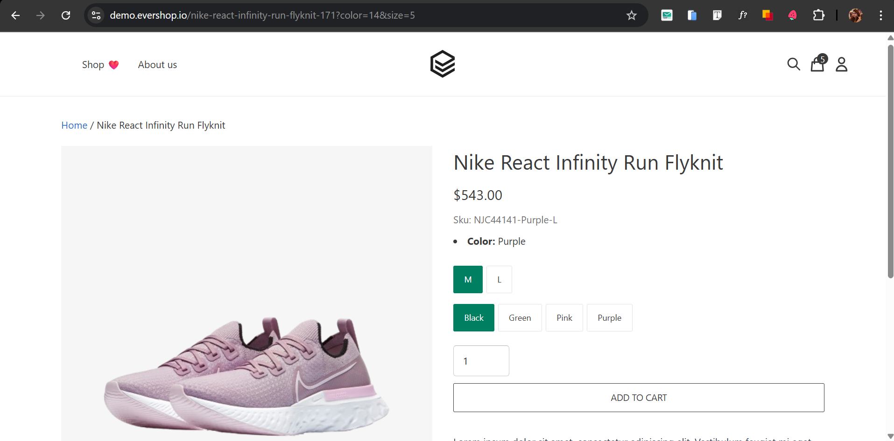

- If the user doesn’t select the product’s size or colour then the add to cart button is not functional and it is showing an error message , but as a user i would suggest a pop up error message that will draw the users attention easily .
- If the user doesn’t select the product’s size then the add to cart button is not functional but it is not showing an error message accurately that the user has not chosen any size it is only showing the previous error message the message should be more accurate to the user .
- Shoes sizes that are not available that are not showing in the first place to the user but when the user selects the color then the size icon is showing grey , in my analysis it should show to the user in the first place. It would be user friendly .
- In the API request if I change the size to 4 which is not available among the products it is not showing any error message it is showing the response code 200 which is a successful code .It is a bug.

API collection share link :

https://www.postman.com/descent-module-observer-27745419/assignment-project/collection/o061sbg/evershop?action=share&creator=25733743

